**DAILY ONLINE ACTIVITIES SUMMARY**

|  |  |  |  |  |  |  |
| --- | --- | --- | --- | --- | --- | --- |
| **Date:** | **28 may 2020** | | | **Name:** | **KHATHEEJA SAFREENA** | |
| **Sem & Sec** | **4th sem, 2nd year** | | | **USN:** | **4AL18CS037** | |
| **Online Test Summary** | | | | | | |
| **Subject** | **MICROCONTROLLER AND EMBEDDED SYSTEMS (18cs44)**  **AADALITHA KANNADA.** | | | | | |
| **Max. Marks** | **20(mes), 50(kannada)** | | **Score** | | **19(mes)**  **18(kannada)** | |
| **Certification Course Summary** | | | | | | |
| **Course** | **INTRODUCTION TO DIGITAL MARKETING.** | | | | | |
| **Certificate Provider** | | **Great learning** | **Duration** | | | **2.5 HOURS** |
| **Coding Challenges** | | | | | | |
| **Problem:**  **1 program executed** | | | | | | |
| **Status: executed** | | | | | | |
| **Uploaded the report in GitHub** | | | **YES** | | | |
| **If yes Repository name** | | | **[http://github.com/shafreenasharief/lockdown-coding](http://github.com/shafreenasharief/lockdown-coding" \o "http://github.com/shafreenasharief/lockdown-coding)**  **[http://github.com/shafreenasharief/locked-down--certification-course](http://github.com/shafreenasharief/locked-down--certification-course" \o "http://github.com/shafreenasharief/locked-down--certification-course)** | | | |
| **Uploaded the report in slack** | | | **YES** | | | |

Online Test Details: (Attach the snapshot and briefly write the report for the same)

Certification Course Details: (Attach the snapshot and briefly write the report for the same)

Coding Challenges Details: (Attach the snapshot and briefly write the report for the same)

**ONLINE TEST SUMMARY**:

* **MICROCONTROLLER AND EMBEDDED SYSTEMS (18cs44) the test was from 2nd module of 20 marks at 11:30 Am**

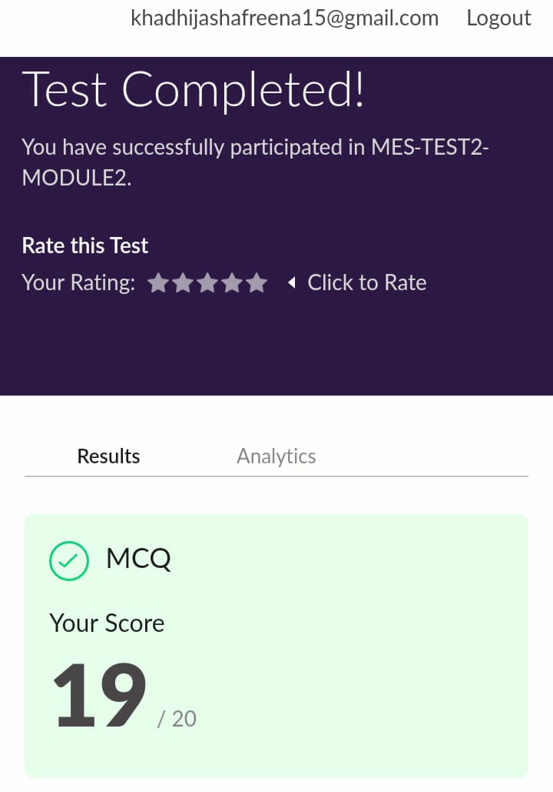

* Today Adalitha kannada test was conducted for 50 marks at 2:00Pm for 50 minutes. 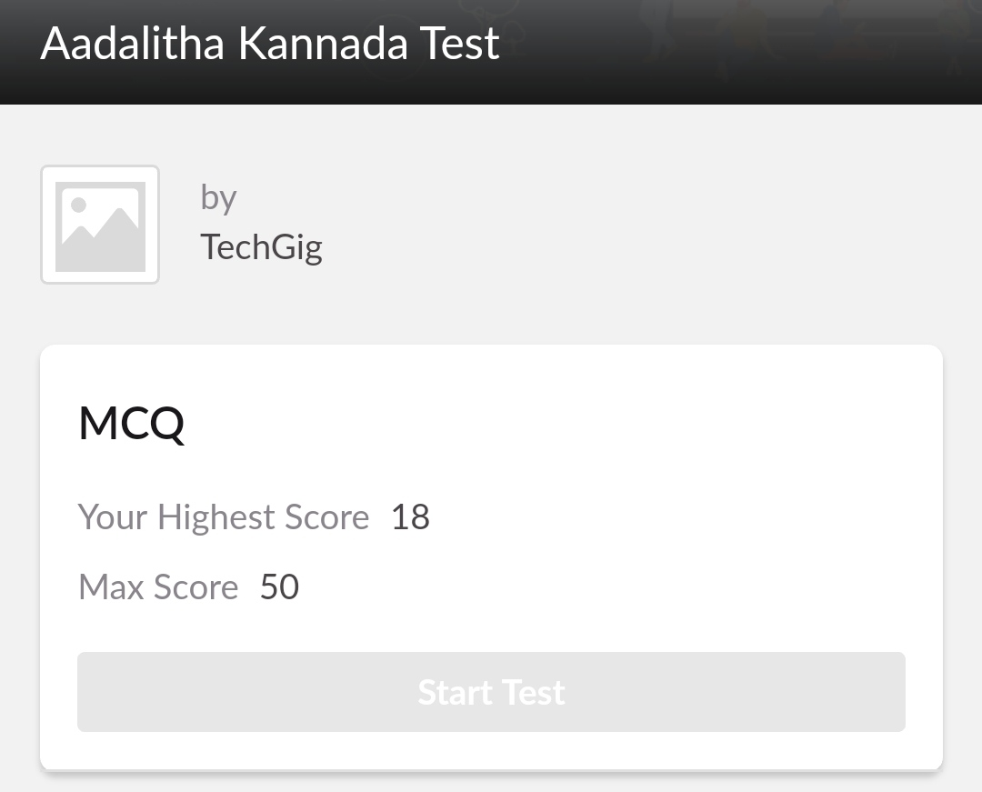

**ONLINE CERTIFICATION COURSE:**

* I'm doing certification course on INTRODUCTION TO DIGITAL MARKETING on great learning.The course is secluded for 2.5 hour.Today I completed 3 module which is Facebook interface & types of Audience, Adset Set up guide .I attempted quiz which gave me a clear veiw about the topics that were thought and discussed.
* It consists of 10 modules including assessments.

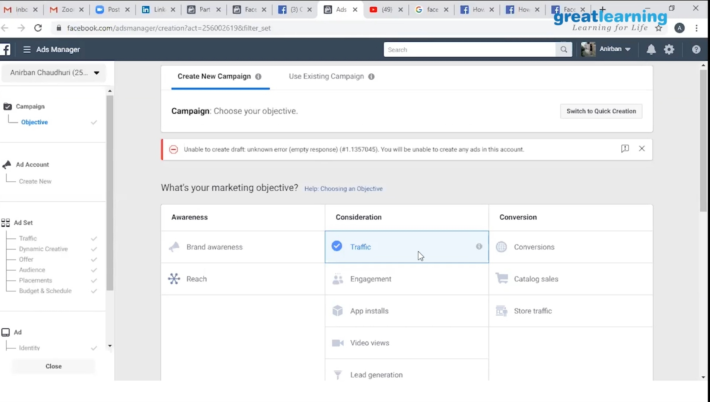

**ONLINE CODING SUMMARY**:

**C program to find digital root of a number**.

1. Description:  
   A digital root is the recursive sum of all the digits in a number. Given n, take the sum of the digits of n. If that value has more than one digit, continue reducing in this way until a single-digit number is produced. This is only applicable to the natural numbers.  
   digit root (0) = 0
2. digital root (16)  
   => 1 + 6  
   => 7

1. digital root (132189)  
   => 1 + 3 + 2 + 1 + 8 + 9  
   => 24 ...  
   => 2 + 4  
   => 6

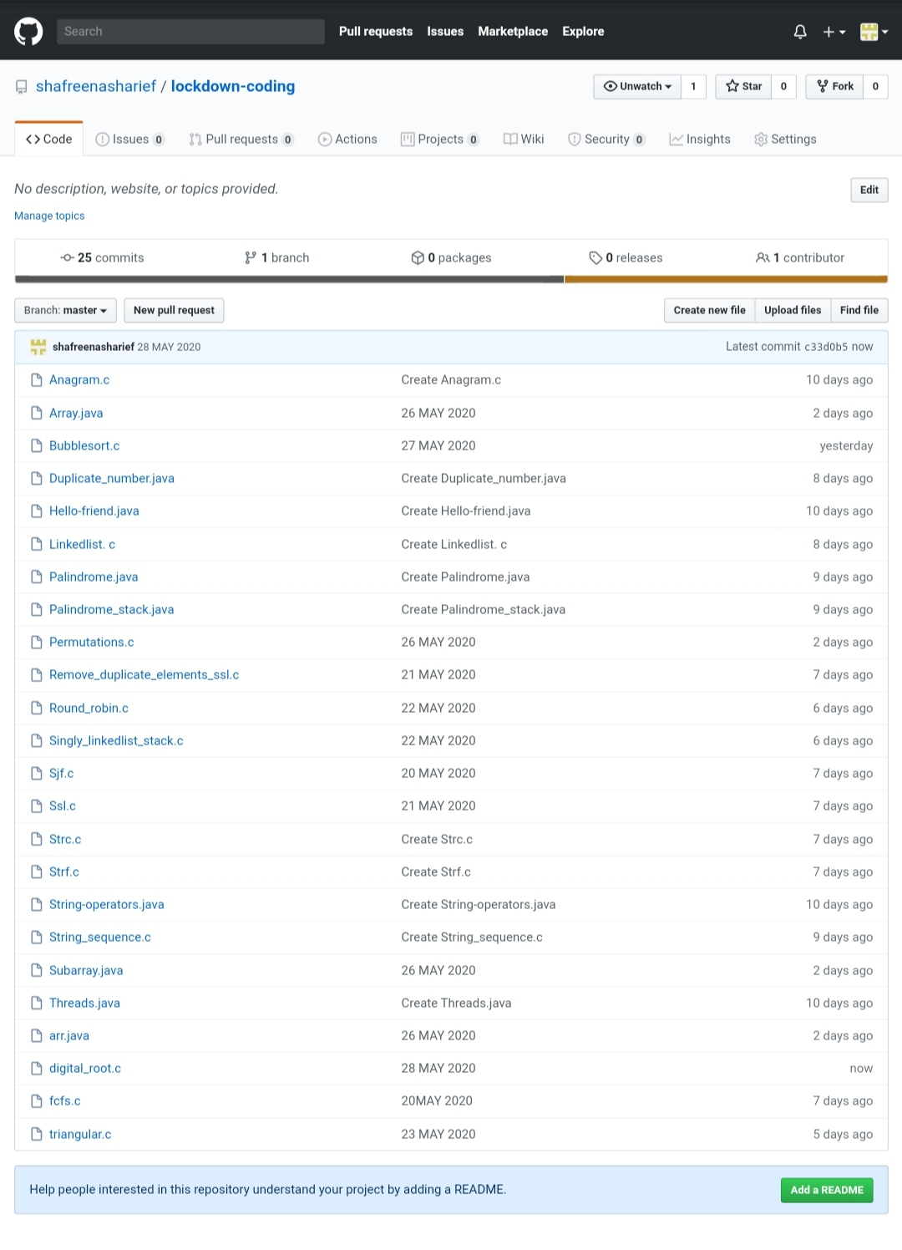

**SOLUTION : I have uploaded the solution of the above 4 coding problems in my GitHub repository.**

**[http://github.com/shafreenasharief/lockdown-coding](http://github.com/shafreenasharief/lockdown-coding" \o "http://github.com/shafreenasharief/lockdown-coding)**

**[http://github.com/shafreenasharief/locked-down--certification-course](http://github.com/shafreenasharief/locked-down--certification-course" \o "http://github.com/shafreenasharief/locked-down--certification-course)**

**[http://github.com/shafreenasharief/Daily_Report](http://github.com/shafreenasharief/Daily_Report" \o "http://github.com/shafreenasharief/Daily_Report)**